

**REPORT**

**ON**

**TATA CONSULTANCY SERVICES (TCS)**

**REAL239 – Basics of Real Estate Transactions**

**SUBMITTED BY -** **Abhishek Chauhan (A13558822008)**

**Dikshay Chauhan (A13558822010)**

**Under the guidance of Prof. Rekee Prashar**

**TABLE OF CONTENTS**

**INTRODUCTION (About the company)** 3

**FINANCIAL INFORMATION** 4

**PURPOSE OF EXPANSION** 4

**DETAILS OF PROJECT** 5

**DEVELOPMENT PLAN** 6

**APPLICABLE LEGISLATIONS** 6

**SORRUNDINGS** 7

**PROJECT COST** 7

**WATER REQUIREMENT** 8

**VEHICLE PARKING FACILITIES** 8

**POWER REQUIREMENT** 8

**MATERIALS USED FOR CONSTRUCTION** 8

**OTHER SUITED OPTIONS** 8

**TRANSACTION PROCESS** 9

**REFERENCES** 13

**TATA CONSULTANCY SERVICES (TCS)**

# **INTRODUCTION (About the company)**

TCS which stands for Tata Consultancy Services is one of the top IT Company in India. TCS is a multi-national company which provides IT and other services including consulting, business solutions while collaborating with various world’s largest businesses (like Syndigo, Shure Inc., Xynteo, Enento Group and others). TCS is continuing doing the same for more than past 50 years with excellence.

TCS works and provides technical services in many different industries like banking, education, healthcare, insurance, communication & media, manufacturing, retail, energy & resources, consumer goods, travel and others. These services includes cloud, cybersecurity, data & analytics, IoT, block chain, AI and sustainability services.

TCS is one of the top information technology company in India with more than 6 lacs+ employees, hiring thousands of employees every year.

* A MNC operating worldwide
* Subsidiary of esteemed TATA group
* Offering services across 10+ different industries
* Involved in data analytics, automation, AI, block chain and other areas.

## **FINANCIAL INFORMATION**

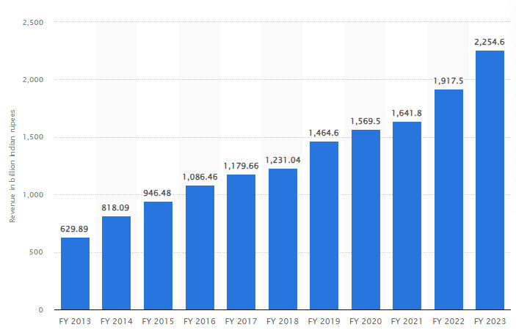The total revenue generated by TCS in the year ended at 31st March 2023 was around $27.9 billion (INR 225,460 crore) and it is listed on the NSE and BSE in India.

(Source: <https://www.statista.com/statistics/759883/india-tcs-annual-revenue/>)

## **PURPOSE OF EXPANSION**

There are many TCS centers across India, boosting its presence in the country.

* The HQ (Head Quarters) of TCS is located in Mumbai.
* Gurugram, Noida and Delhi is hub for TCS with many centers.
* TCS back-office operations center in Kolkata.
* Chennai is a hub for IT & ITES for TCS.
* New TCS Noida ITSEZ Campus in Sector 157.

For the expansion of new center in Noida Sector 157, TCS states the purpose is to **accommodate the company's growing workforce and operations**.

**Increased Capacity:** The project will create more space for TCS to support its expanding workforce and operations. This aligns with their earlier announcement of an investment of ₹1010 crore and creation of over 30,000 new jobs in the region.

**Increased demand:** TCS is witnessing constant growth, evident in its increasing workforce and client base. This requires additional space to support new employees and cater to the growing demand for their services.

**Government Incentives:** TCS has been benefited with government incentive from Uttar Pradesh government of INR 1.78 billion for setting up TCS ITSEZ center in Noida, Sector 157.

**Streamlining and Efficiency:** A larger, centralized campus potentially streamlines the operations and boost the overall efficiency for TCS.

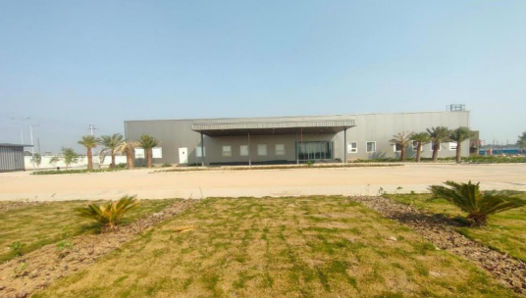

(IDC Building; Source: <https://www.tcs.com/content/dam/global-tcs/en/pdfs/who-we-are/compliance/Noida-it-sez-Campus-Half-Yearly-June-2022.pdf>)

# **DETAILS OF PROJECT**

**Name:** TCS Noida ITSEZ Campus

**Address:** Plot No.1, Sector 157 Noida, Gautam Budh Nagar, Uttar Pradesh

**Project Proponent:** Tata Consultancy Services Ltd (TCS)

**Project Site Area:** 26.266 hectare (2,92,660 sq. m)

**Land Cost:** INR 6.88 billion

**Maximum No. of Floors:** 2 Stilt + 2 Podium + 1 Mezzanine + 12 Floors

**Maximum Height of Building:** 75 meter

**Permissible FAR:** 2.5 of Plot Area (Proposed FAR: 0.5 of Plot Area)

**Permissible Ground Coverage:** 35% of Plot Area (Proposed GC: 20.74%)

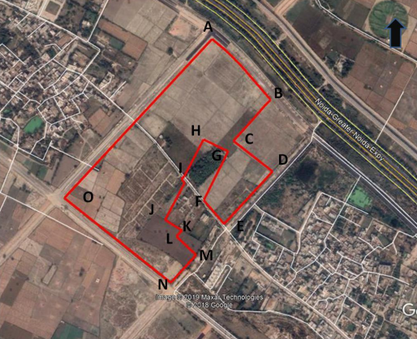

(Source: <https://environmentclearance.nic.in/writereaddata/FormB/TOR/ConceptualPlan/28_Aug_2019_140246273HKBMFUEKCP_TCS_08082019_Rev1_KS-converted.pdf>)

## **DEVELOPMENT PLAN**

This project of TCS will be developed in phases I & II.

**Area of Phase I:** 2,31,821.05 sq. m

**Area of Phase II:** 60,838.95 sq. m

**Total Built-up Area (Phase I):** 2,46,761 sq. m

* Currently Phase I will be developed first and the Phase II will be further developed in future.
* Proposed project will comprise of the following features: 1 Transit Hub, 3 SDB towers with podium with 2 stilt parking levels, 1 welcome block, 1 utility block, 1 Development Centre, 1 main security house, 1 temporary gate house with 3 security cabins, playground and food court with other additional services like water supply infrastructure, storm water network, green spaces and waste management system.

## **APPLICABLE LEGISLATIONS**

TCS project Noida has to obtain environmental clearance from SEIAA (State Environmental Impact Assessment Authority), Uttar Pradesh. Other legislations applicable are:

• Environment Protection Act, 1986

• EIA Notification, 2006 as amended (Activity 8(b) & Category B1)

• Air Act, 1981

• Water Act, 1974

• Solid Waste Management Rules, 2016

• Construction & Demolition Waste Management Rules, 2016

• Plastic Waste Management Rules, 2016

• Hazardous & Other Waste Management Rules, 2016

• E-Waste (Handling & Management) Rules, 2016

• NBC Code 2016

• NOIDA Authority Local Bylaws

## **SORRUNDINGS**

**Near-by Residential Area**

**Nearest Educational institute**

• GNIT college of Management (3.6Km, East)

• Galgotiya College of Engineering and Technology (3.9Km, East)

• Sector-159, Noida (160 m, NW)

• Village Badauli Khader (100m, SE)

• Village Gulavali (1.2 Km, NWW)

• Village Kambakshpur (940 m, SW)

**Nearest Hospital**

• ITS Surya Hospital (2.9 Km, ENE)

• Sharda Hospital (2.8 Km, NE)

**Nearest Industrial Area**

• Noida Phase 2 (9 Km, NW)

**Nearby Water bodies**

• Hindan River (0.8 Km, NE)

• Yamuna River (1.8 Km, SW)

## **PROJECT COST**

The cost of the TCS project at Noida Sector 157 is around INR 1,010.82 crores.

## **WATER REQUIREMENT**

In the construction phase of the project, the water will be provided by the Noida Authority from the sewerage treatment plant and private water taker supplier for the use of the labor working on site.

* Water req. for domestic use by labors: 40 KLD
* Water req. for construction purpose: 50 KLD
* Total water req. will be approx.: 1124 KLD

After the construction, municipal supply will be used for water needs for operational requirements.

Wastewater treatment will also be carried out in the facility and rain harvesting will also be done.

## **VEHICLE PARKING FACILITIES**

As per parking norms, No. of car parking required = FAR/50 sq. m

Car parking provided = 3862 (1334 Surface parking; 2528 Stilt parking)

## **POWER REQUIREMENT**

TCS project’s power requirement is 10.417 MVA.

## **MATERIALS USED FOR CONSTRUCTION**

* Cement
* Steel
* Sand
* Aggregate

1. Walls: Brick (Fly Ash), AAC blocks, Tiles
2. Roofs: RCC slab, water proofing
3. Floors: Concrete floor, vitrified tile, kota stone, granite
4. Windows: Double glazed on external facade

## 

## **OTHER SUITED OPTIONS**

**1. Expanding existing facilities:** Expanding the existing facilities might have been cost effective and quicker than making a new facility. But, a new facility would provide with modern infrastructure and centralized work environment.

**2. Setting up in a different location:** Planning the facility in a different depending on the land cost and availability. Government incentives in certain areas with more opportunities. There are other SEZ areas in Noida, Sector 145, 146, 147, 166, 165, 164, 156 and 155.

**3. Utilizing hybrid work model:** TCS could reduce need for physical work space and could have opted for a hybrid mode of working. But this could hinder certain business operations and collaboration opportunities.

# **TRANSACTION PROCESS**

The land for the development of TCS project in Noida has been allotted by **New Okhla Industrial Development Authority (NOIDA)**. The land use of the following project will remain **ITSEZ** (Commercial Area) as the site is allotted by the Noida Authority only for development of ITSEZ, so no change in land use required.

The process of transaction for ITSEZ development in Noida for the new TCS project in sector 157, involves several steps. Here's a likely detailed breakdown focusing on the specific procedures relevant to Noida:

**1. INITIAL PLANNING AND PROPOSAL (BY TCS):**

TCS prepared a detailed project proposal containing detailed information about their idea of development for the ITSEZ development in Sector 157.

This proposal includes following details like:

* Required land area (as 29.266 hectares available in publicly available documents)
* Proposed building/infrastructure development plan for the campus.
* Expected economic benefits for the region (Potential investments, Job creation)

**2. GOVERNMENT APPROVALS (BY TCS):**

TCS approached the Noida Authority, the governing body for development in Noida, and submitted the proposal for review and approval. This includes: proposal with all details of project, various building plans, layouts, internal and external designs, and other documents.

This process involved discussions and negotiations with the Noida Authority regarding the project's benefits and alignment with Noida's development goals so all can get benefits from the subject project - the organization itself, the government and the general public.

**3. LAND IDENTIFICATION (BY NOIDA AUTHORITY):**

Considering the project scale, Noida Authority likely identified a suitable land parcel within their designated ITSEZ land bank in Sector 157. This ensures the project aligns with Noida's plans for IT development in the area.

There are various sectors which comes under SEZ land use areas, but as all areas are not available at the time, so the land parcel available at that time that meets all needs of the project was chosen i.e., sector 157 land parcel. It is near to the Noida Greater-Noida Expressway and is corner property with multiple access points.

**4. LAND ALLOTMENT (BY NOIDA AUTHORITY):**

Land Allotment: If suitable government land was available in the land bank, the Noida Authority might have directly allotted the land parcel to TCS through a lease agreement.

In the following case, no conversion of land use was carried out, as the existing land use was same as required by the project.

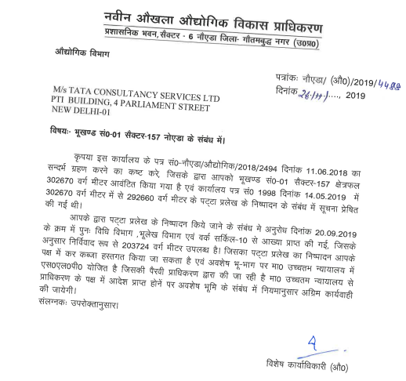

(Allotment Letter of TCS land parcel)

**5. LAND ACQUISITION (BY BOTH):**

Land Allotment Scenario: If land allotment occurred, the process would likely have involved the Land Acquisition Act (LARR), 2013, for any previous private ownership. This entails procedures like compensation and dispute resolution (if necessary).

**6. LEASE AGREEMENT (BY BOTH):**

Regardless of the land acquisition method, a formal lease agreement between TCS and Noida Authority would be established.

This agreement would detail:

* Land use terms and conditions for the ITSEZ development.
* Development timelines for the project
* Infrastructure development responsibilities (shared or separate for TCS and Noida Authority)
* Lease fee and other associated charges

**7. LEGAL DUE CILIGENCE**

Legal due diligence involves comprehensive review of the documents related to sale and purchase of the land and legal documents related to the land parcel.

Includes verifying chain of ownership, permitted use and use history, encumbrances, liens, disputes, litigations, legality of development, mortgages and any claims.

It is the in depth analysis of the property documents, verifying every aspect of the property.

**8. PROJECT DEVELOPMENT AND ITSEZ NOTIFICATION (BY TCS):**

* Upon securing the land through the lease agreement, TCS could begin construction and infrastructure development as per the approved plan
* Once operational, TCS would need to apply for formal notification of the ITSEZ from the Ministry of Commerce and Industry (Department of Commerce).
* ITSEZ notification grants the project special economic zone status with benefits like tax exemptions and duty-free imports.

**OTHER IMPORTANT CONSIDERATIONS:**

**Environmental Clearances:** Obtain environmental impact assessments (EIA) and approvals from the Uttar Pradesh Pollution Control Board (UPPCB) before commencing development.

**Utility Connections:** Secure temporary and permanent connections for water, electricity, sewage, and other utilities from Noida Authority or designated service providers.

**Infrastructure Development:** Building internal roads, transportation networks, and other essential infrastructure within the ITSEZ falls under TCS’s responsibility.

**Construction Approvals:** Building permits and approvals for construction activities need to be obtained from the Noida Authority's building department. This ensures compliance with building codes and safety regulations.

# **REFERENCES**

Anon., 2019. *Conceptual Plan.* [Online]   
Available at: https://environmentclearance.nic.in/writereaddata/FormB/TOR/ConceptualPlan/28_Aug_2019_140246273HKBMFUEKCP_TCS_08082019_Rev1_KS-converted.pdf  
[Accessed 3 March 2024].

statista, 2023. *Annual revenue of Tata Consultancy Services (TCS) worldwide from FY 2013 to FY 2023.* [Online]   
Available at: https://www.statista.com/statistics/759883/india-tcs-annual-revenue/  
[Accessed 3 March 2024].

TATA Consultancy Services Limited, 2024. *WHO WE ARE.* [Online]   
Available at: https://www.tcs.com/who-we-are  
[Accessed 3 March 2024].

TATA Consultancy Services Limited, n.d. *TCS Annual Report 2019-20.* [Online]   
Available at: https://www.tcs.com/content/dam/tcs/investor-relations/financial-statements/2019-20/ar/annual-report-2019-2020.pdf  
[Accessed 3 March 2024].

Tata Sons Private Limited, 2024. *Tata Consultancy Services.* [Online]   
Available at: https://www.tata.com/business/tcs  
[Accessed 3 March 2024].

tcs, 2022. *Noida-it-sez-Campus-Half-Yearly-June-2022.* [Online]   
Available at: https://www.tcs.com/content/dam/global-tcs/en/pdfs/who-we-are/compliance/Noida-it-sez-Campus-Half-Yearly-June-2022.pdf  
[Accessed 3 March 2024].